**Team 2: Event Plan**

## **Event name: Mission Astra - The Rise of Asura**

## **Event Overview**

*Mission Astra – The Rise of Asura* is a **branch-neutral,** story-driven adventure that fuses logic, creativity, and teamwork within an engaging fantasy narrative.  
Teams must conquer **three stages**, earning **five Astras (weapons)** by solving puzzles, riddles, and challenges to ultimately reach the *Asura*.

## **Event Summary**

### The event has three exciting rounds - **Round 1 -** Teams will play an online puzzle game built as a website. The puzzle contains scrambled image pieces that, when correctly arranged, reveal an Astra, within a time limit. **Round 2 -** “The Chaturaasthanas” happens in Room 110, where teams have to go through four unique “Aasthanas” challenges to earn Astras 2, 3, 4, 5 through different tasks. **Round 3 -** Finally, in **“**The Rise of Asura**”**, teams return to Sir MV Hall to face one of twelve forms of the Asura. Using all five Astras, they must arrange them correctly to defeat the Asura - and the first three to succeed are crowned winners.

## **Complete Storyline**

Kindly find the storyline in the attached document: [storyline.pdf](https://drive.google.com/file/d/1cIkNHXuavj-4JVZQNiZULYh0r736j9Fo/view?usp=sharing)

## **Event Details**

* **Type of event:** Fun + Tech event, leans more towards being a fun event
* **Date:** 29th October 2025, Wednesday
* **Time:** 5:30 pm onwards
* **Duration: Event’s duration -** 2 hrs**, Game duration -**  90-100 minutes
* **Venue:** Sir MV Hall and Room 110, NIE South Campus
* **Participants:** 60 (Limited seats, FCFS basis)
* **Target audience:** Primarily first and second year students
* **Team Size:** 5 members in 12 teams

## **Event Flow**

### Round 1 – The Realm of Mind (Puzzle of Precision)

* **Mode:** Online (Website)
* **Venue:** Sir MV Hall
* **Objective:** Collect Astra 1, by solving the puzzle correctly
* **Description:**-Teams will take on a digital jigsaw puzzle challenge designed to test focus and coordination. Each team must complete a 6x6 jigsaw puzzle that reveals the image of *Astra 1*. The faster the team completes the puzzle, the sooner they can proceed to the next round.  
  - The contest runs in real-time, with each team accessing the puzzle through a provided website link. A team can use only one device to solve the puzzle. Once a team successfully completes the puzzle, they will receive confirmation from volunteers and can move on to *Round 2*, conducted in Room 110 — the Chaturaasthanas.
* **Result:**   
  Teams move to the next round, being conducted in room 110. Hence moving out of the MV Hall, to the Chaturaasthanas.
* **Scoring:**   
  - The primary factor is **completion time** — faster completion means higher rank.

- In case of identical completion times, teams will be sent out simultaneously.

* **Volunteers:**One volunteer will be assigned per team to handle point assessment and crowd control. This volunteer will escort their respective team from MV Hall to Room 110 for Round 2. With 12 teams, there will be 12 volunteers. Additionally, two volunteers will handle the database/backend and another one will present a path between room number 110 and MV Hall.

### Round 2 – The Chaturaasthanas (The four courts)

*The above photo shows the intended layout of room 110*

* **Mode:** In person
* **Venue:** Room 110, Shift one court to Sir MV Hall
* **Objective:** Collect Astra 2, 3, 4, 5 by solving challenges in each Aasthana
* **Description:  
  -** The room 110 is divided into four “Aasthanas”, where they solve challenges to gain an Astra from each of the Aasthanas. All the teams will be assigned scores based on their performance in each Aasthanas, which will be considered to decide the winning teams.  
  - Once they finish the challenges in each court, they will face another small fun activity, which will reward them with the Astra.
* **Conditions to qualify to the next round:** Collect Astras 2, 3, 4, 5
* **Result:** Teams move to the next round, being conducted in Sir MV Hall.
* **Scoring:   
  \*** Collect Astras 2, 3, 4, 5  
  **\***  Each Aasthana will record the score of each team as they finish their challenges.   
  **\*** Each Aasthana will reward the teams with 10 points, with a penalty of -3 points if they breach the allotted time.
* **Volunteers:** At each Asthana (counter), the volunteer assigned to the respective team will manage the riddles and fun challenges. Each volunteer will monitor their team and handle scoring. With 12 teams, there will be 12 volunteers, and an additional 3 volunteers will assist with crowd management and any unforeseen issues.

### Round 3 – The Rise of Asura (Boss Battle)

* **Mode:** Website
* **Venue:** Sir MV Hall
* **Objective:** Meet the Boss Asura
* **Description:  
  -** The Asura takes up one of twelve forms, each described by a different combination of layered powers. The teams are randomly assigned one of the twelve forms of the Asura to be defeated.  
  - The teams are asked to arrange the five Astras in a particular sequence, which shall progressively penetrate through each of the layers and meet the Asura at the end.
* **Result:** The teams are awarded with a score based on the number of questions answered correctly.
* **Scoring:** Each correctly answered blank carries 10 points, with no penalty for wrongly answered blanks.
* **Volunteers:** Volunteers will return with their respective teams to MV Hall and coordinate the assigned tasks.

## **Takeaway**

* Fun time with fellow team members.
* Revision of technical concepts

## **Additional Information:-**

### **Marketing ideas**

* One Instagram reel, which shall give a glimpse of the storyline.
* One short video to post on Instagram story on the day of the event.
* Marketing posters (A3) and instagram post (1:1)
* Write-up
* Classroom announcements
* Class group advertisement
* (permission required) interaction with the audience for promoting the event

### **Creativity works along for preparing and assembling them**

#### **1. Event Title Display – “Mission Astra: The Rise of Asura”+ Astra Pathway Display**

* Use the idea below to represent the logo of the event. It shall be kept outside the Sir MV Hall for the participants to look at.
* The circles shall contain images representing each of the **five Astra symbols** which the participants will find.
* Also on chalk board in sir mv hall either draw or stick pictures of swords and related pictures.
* 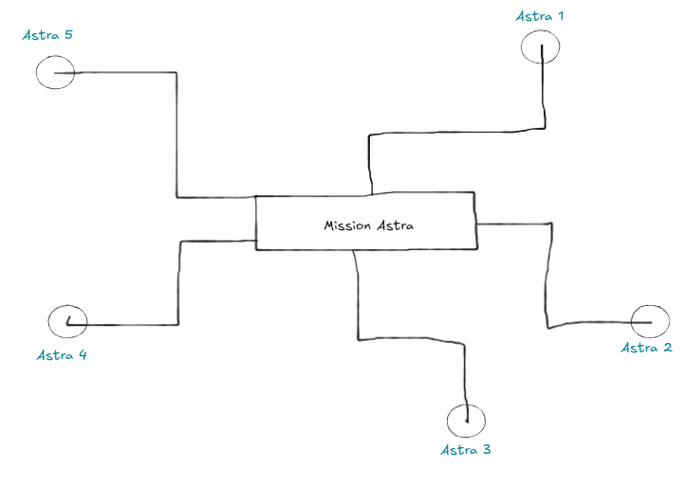

**2. Ancient Scroll Prop (Symbolizing Astra Knowledge)** 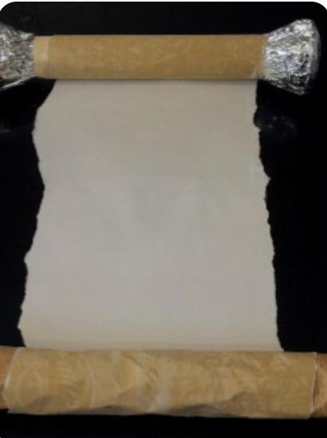

#### Create scrolls inspired by *the image* using paper rolled at both ends with sticks. These scrolls can represent **ancient Astra knowledge** for each round of the event. We can make this as a props symbolising ancient scrolls.

#### 3. **Hanging Astra Props (Woollen Thread Display)**

#### Prepare mini Astra props using cardboard and attach them to woollen threads. Hang them on the stand used during CASS Fest for 0-1 hanging and place it near/ in room 110.

#### 4. Make a cutout of letters of “**LOADING PLAYERS**” as shown in the image and place it in the MV Hall entrance above the door.

#### 

5. **Asura Character Cut-Out**

* Create a **cardboard cut-out of the Asura character** and place it near **MV Hall**. It can serve as a photo point or symbolic centerpiece of the event.

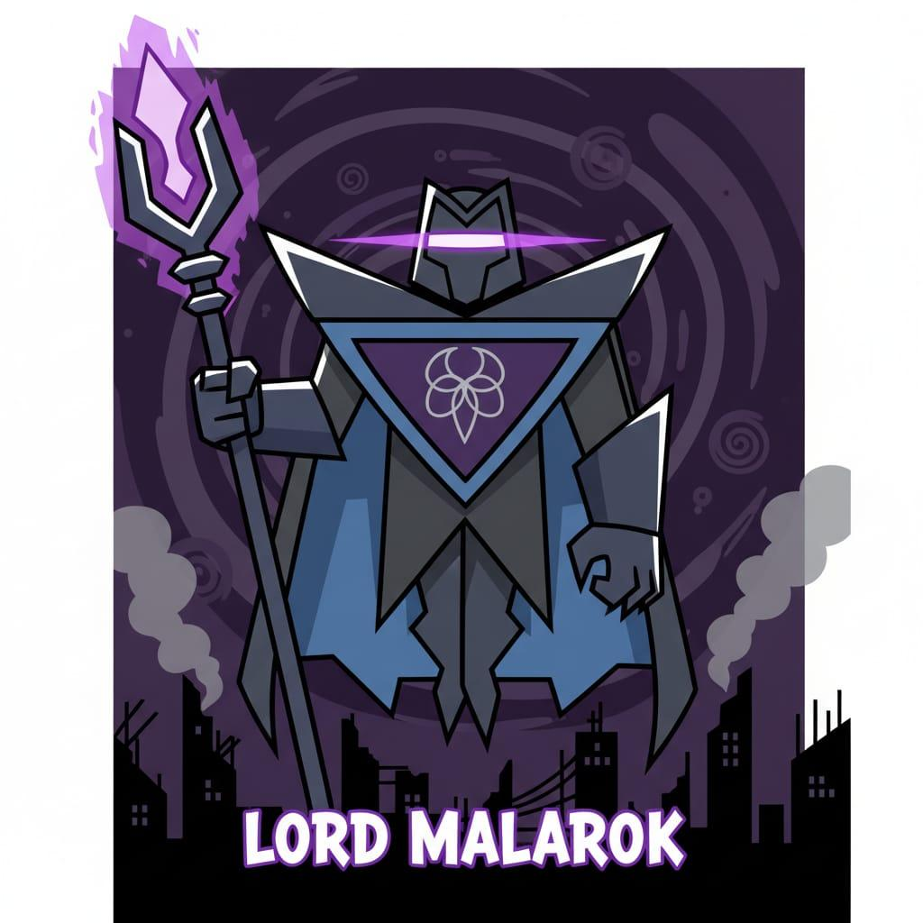

### **Schedule**

### (Total Duration: ~1hr 45 min hours) and Timeline (5:45 PM to 7:45 PM):

### 

### Questions which we will present to the audience

* Riddles in round 2: [Astras for round 02 (1).pdf](https://drive.google.com/file/d/1HW4LooZfrzF3UY64jxHvMNoSvCsITWAL/view?usp=drive_link) **(Kindly refer the Vayu astra, Agni astra, Vajra astra, Bhramastra and Pashupatastra section of the pdf)**
* Challenges in round 2: [Round 2 fun challenges (final - 21 oct) (1).pdf](https://drive.google.com/file/d/1TzNZM0ZZ9lTK85VfCC6yRJFYwVLl4jkJ/view?usp=drive_link)
* Questions in round 3: [round_3.pdf](https://drive.google.com/file/d/1ZF_IxmKizNtYmp-kSerLDyVYrPLrac1N/view?usp=sharing)

### **Tech Stack:**

* Front end: react+css
* Back end: Node+express

### **Logistics:**

* 2 posters(A3)
* A4/newspaper papers for fun activity in round 2
* Prize money envelope
* 5 Cardboards (20 Astras in each cardboard) - for the Astras + creativity work
* Old Posters, Paint box, Scissors, Glue bottles (if not in room)

### **Budget:**

| **Sl. no.** | **Items** | **Quantity** | **Cost per piece (in rs.)** | **Total cost (in rs.)** |
| --- | --- | --- | --- | --- |
| 1 | Prize money envelope | 2 | 2 | 4 |
| 2 | Posters | 2 | 20+gst | 47 |
| 3 | Cardboards | 5 | 7-10 | 50 |
| 4 | Glues | 2 | 10 | 20 |
| 5 | Woolen thread | 1 | - | IEEE Room |
| 6 | A4 sheets | 30 | 1 | 30 |
| 7 | Prize money | 2 | 400+300 | 700 |
| - | **Total cost** |  |  | **851 Rs** |

## **Notes**

● We will try to get as many things as possible from the IEEE room.

● We can also use newspapers instead of 40 A4 sheets and we can reuse any waste bottles.

## **Entry Fee**

● Non-IEEE members: 20 rs

● IEEE members: Free